

SCHOOL: of Computing and Informatics

Department: Department of Information Technology

Submitted by: Mohamed Musa

Registration Number: BSCCS/2024/55412

Unit Title: Advanced Cryptography

Institution: Mount Kenya University

Lecturer: Mr. Micheal Nyoro

Contents
WEEK 1: Environment Setup 4
Installation of kali 4
OPENSSL 4
CHECKING GPG 4
GitHub Repository Initialization 5
Week 2: Classical Cryptography and Cipher Design 6
Caesar Cipher Implementation 6
Encryption process 7
Decryption output 7
User input interface 7
Cipher testing results 8
WEEK 3: Stream Ciphers and Random Sequence Analysis 8
Generating a random data 8
Generate Multiple Random Sequences 9
Entropy Testing 9
Stream Cipher (RC4) Investigation 9
Performance Test 10
WEEK 4: Advanced Encryption Standard (AES) and Block Cipher Operations 11
AES Encryption setup 11
Key/Password-Based Encryption Process 11
File Encryption Demonstration 12
AES Decryption Results 12
AES Performance Testing 13
WEEK 5: IMPLEMENTATION OF RSA ENCRYPTION AND KEY MANAGEMENT 13
RSA Key Pair Generation 13
Generate Public Key 14
Public Key Encryption Process 14
Private Key Decryption Results 14
Secure Message Transmission Demonstration 15
RSA Testing and Validation 15

WEEK 1: Environment Setup

Installation of kali

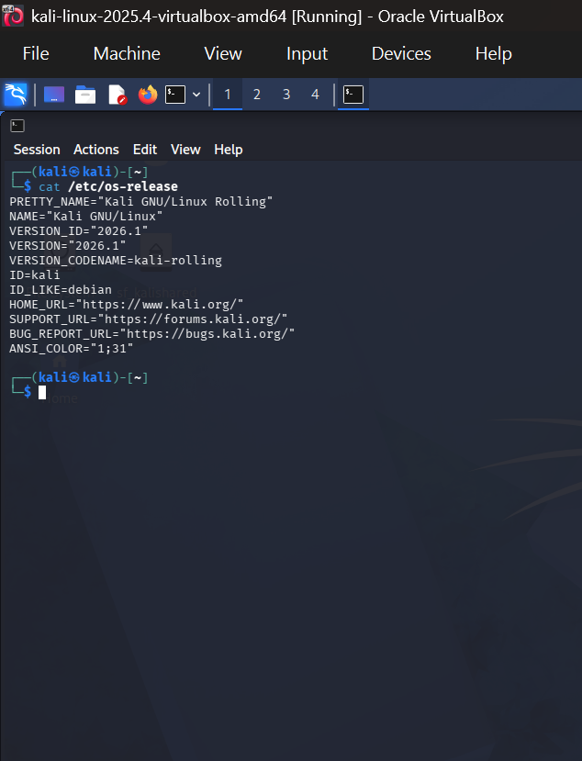

OPENSSL
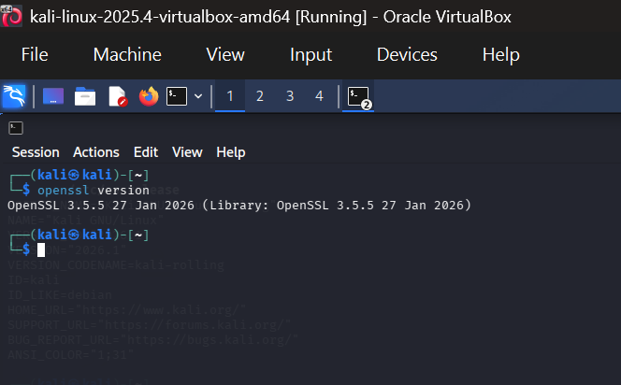

CHECKING GPG
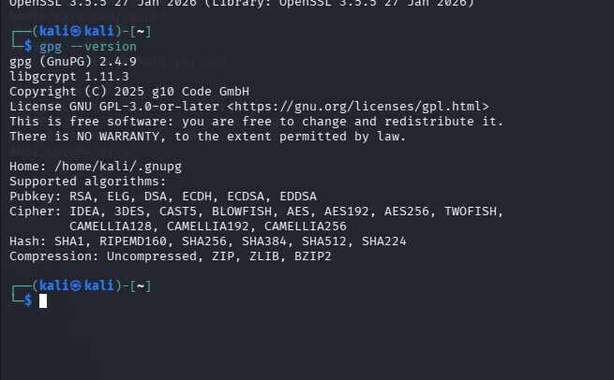

GitHub Repository Initialization
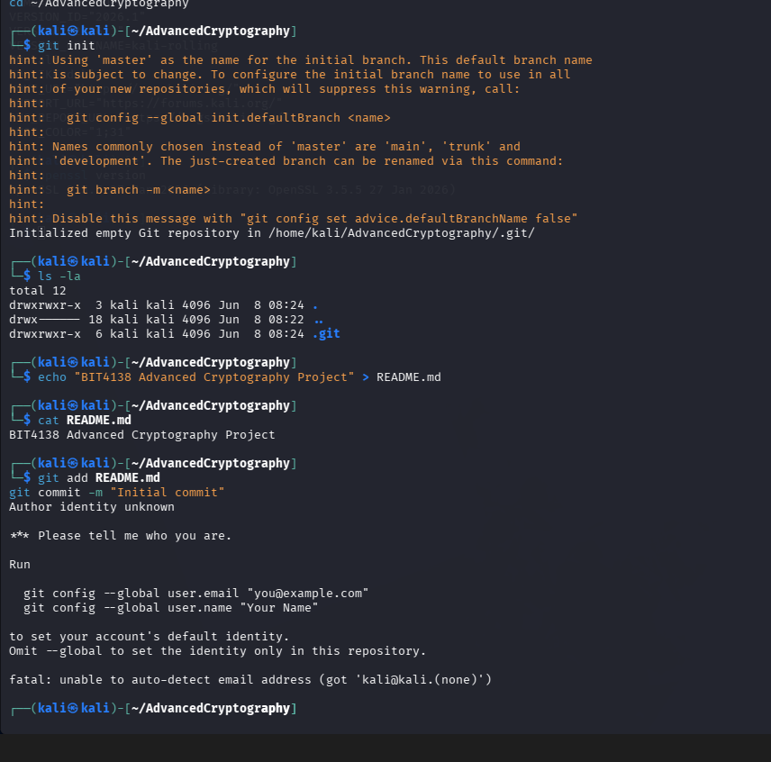

Refection: Kali Linux was configured as the cryptography laboratory environment and initialization of GITHUB

Week 2: Classical Cryptography and Cipher Design

Caesar Cipher Implementation
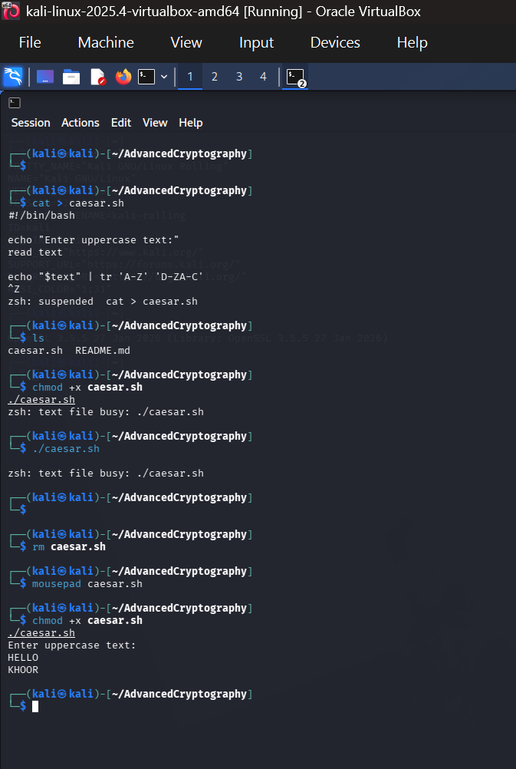

Encryption process
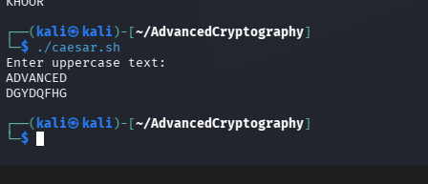

Decryption output
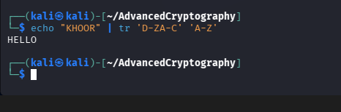

User input interface
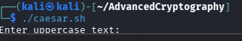

Cipher testing results
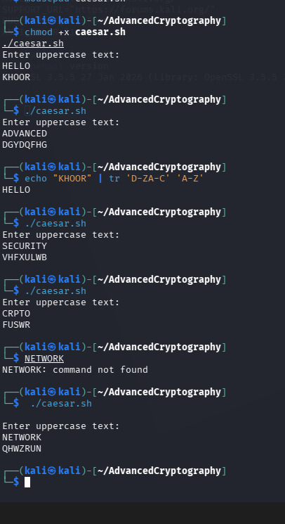
Reflection: The Caesar Cipher was implemented using Bash scripting in Kali Linux and tested many results

WEEK 3: Stream Ciphers and Random Sequence Analysis

Generating a random data
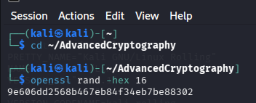

Generate Multiple Random Sequences
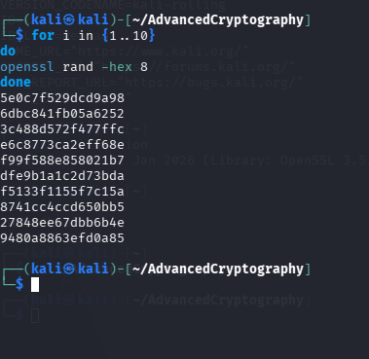

Entropy Testing
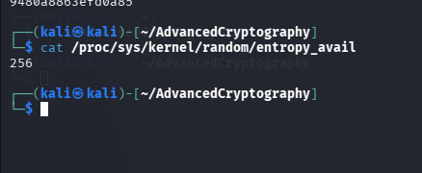

Stream Cipher (RC4) Investigation
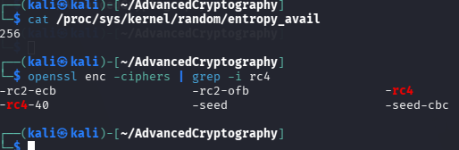

Performance Test
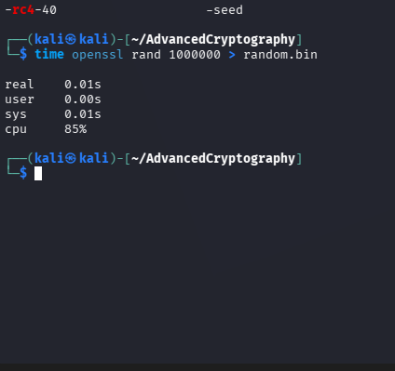

WEEK 4: Advanced Encryption Standard (AES) and Block Cipher Operations

AES Encryption setup
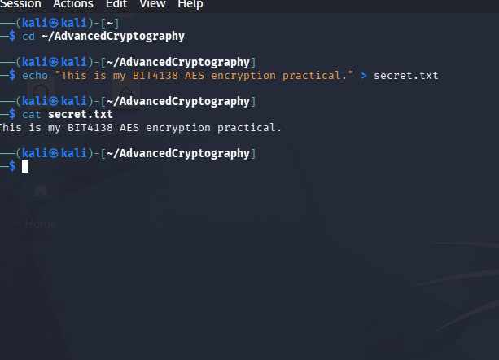

Key/Password-Based Encryption Process
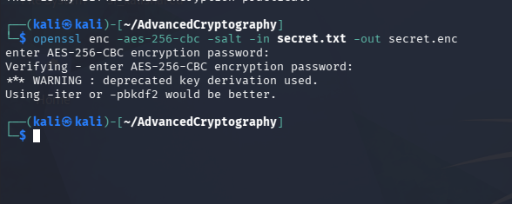

File Encryption Demonstration
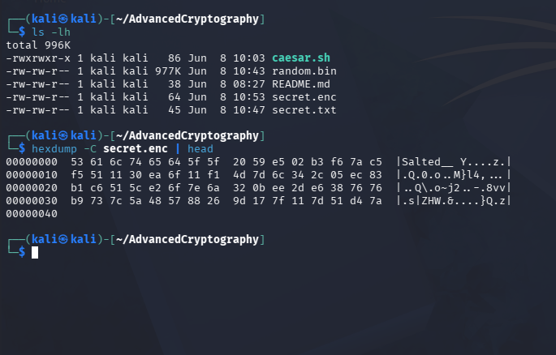

AES Decryption Results
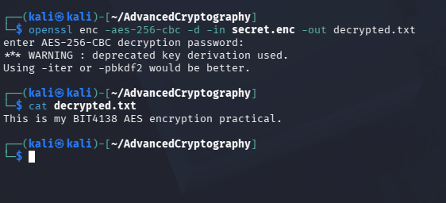

AES Performance Testing
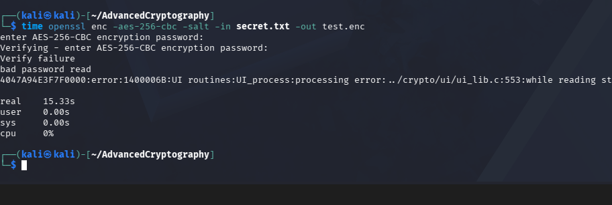Reflection: AES-256 encryption was implemented using OpenSSL to secure a text file.

WEEK 5: IMPLEMENTATION OF RSA ENCRYPTION AND KEY MANAGEMENT

RSA Key Pair Generation
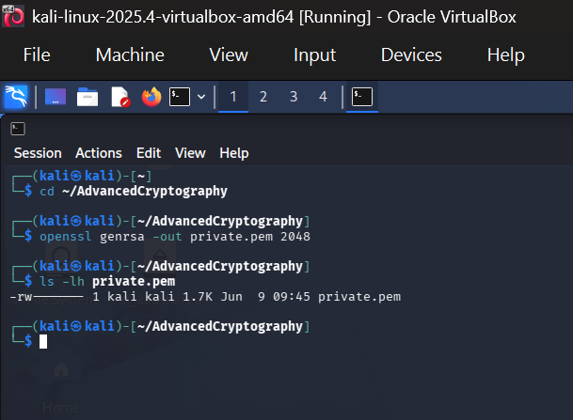

Generate Public Key
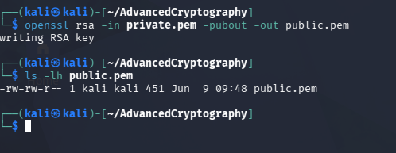

Public Key Encryption Process
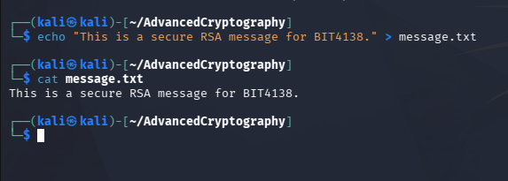

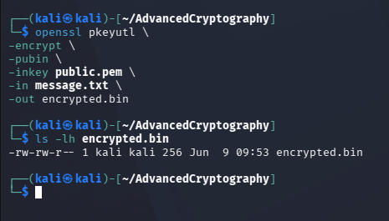

Private Key Decryption Results
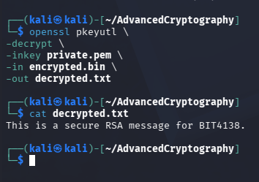

Secure Message Transmission Demonstration
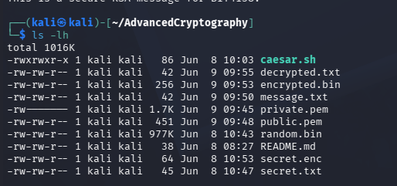

RSA Testing and Validation
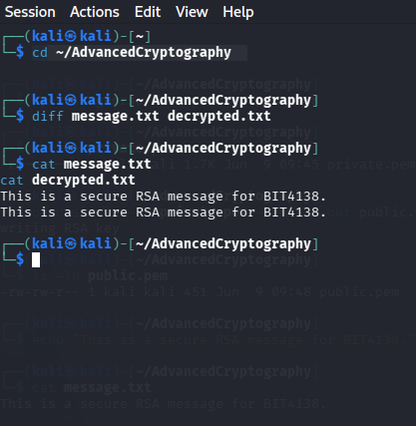

REFLECTION: RSA cryptography implemented using OpenSSL. Public and private keys were generated, and secure message encryption and decryption were successfully performed.

